  LAB10  Timer  Name: 黃翊宏 Student ID: 01357101 |  | Note  - All files must be converted to PDF format before submission.  Submission deadline: Next Tuesday at 1:00 PM  Each person submits one assignment.

- Lab 10

Main Code Screenshot
time.sv:
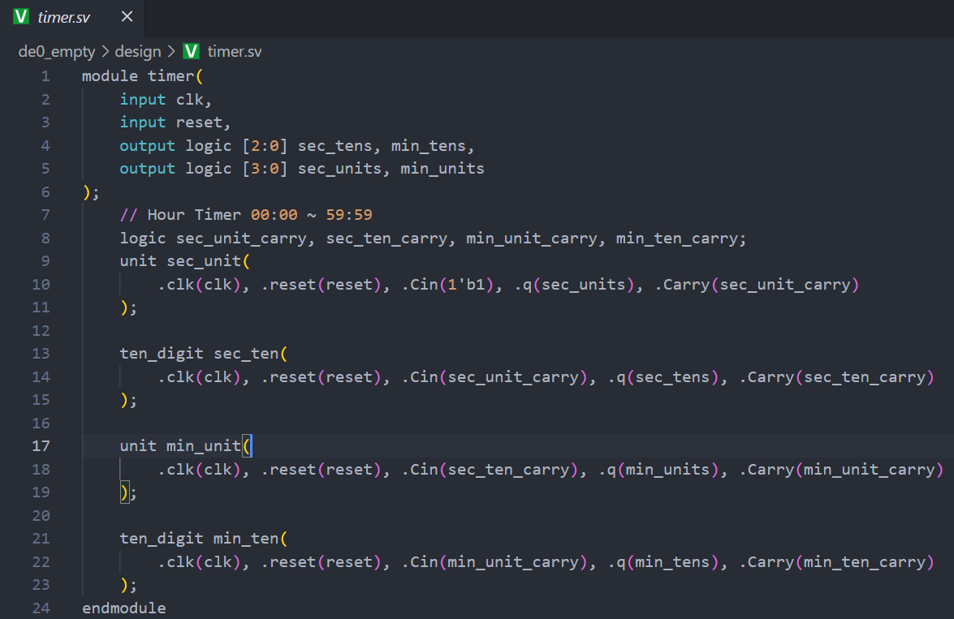
unit.sv
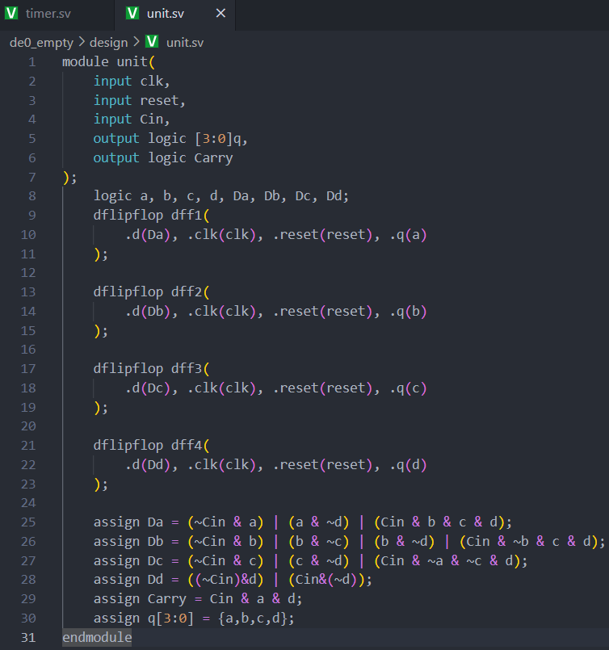
ten_digit.sv
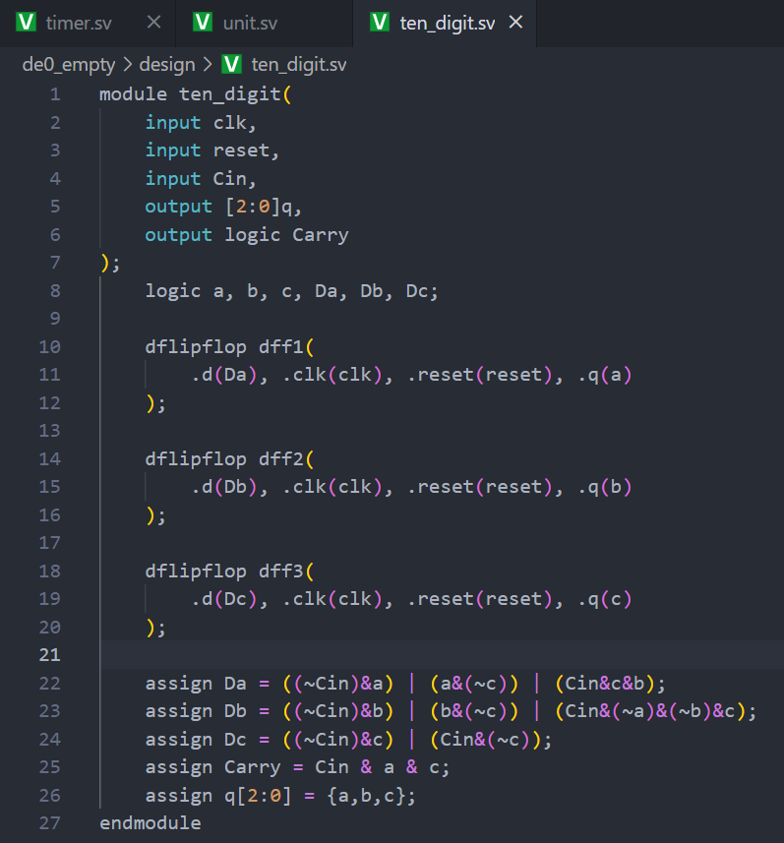
dflipflop.sv
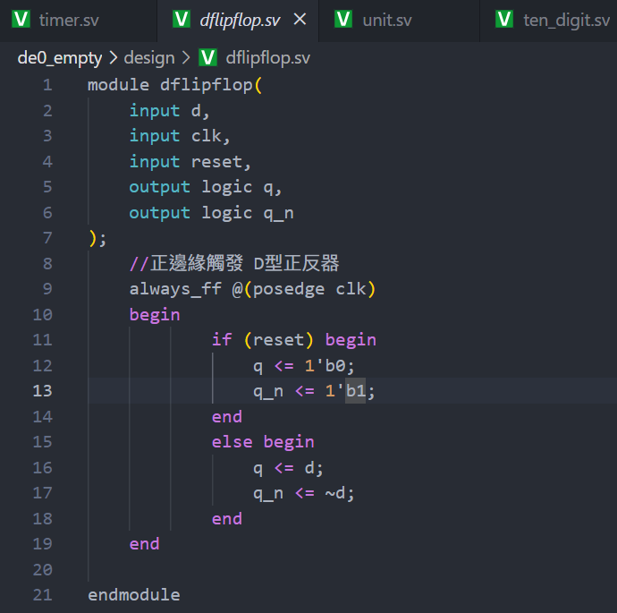
Testbench Screenshot
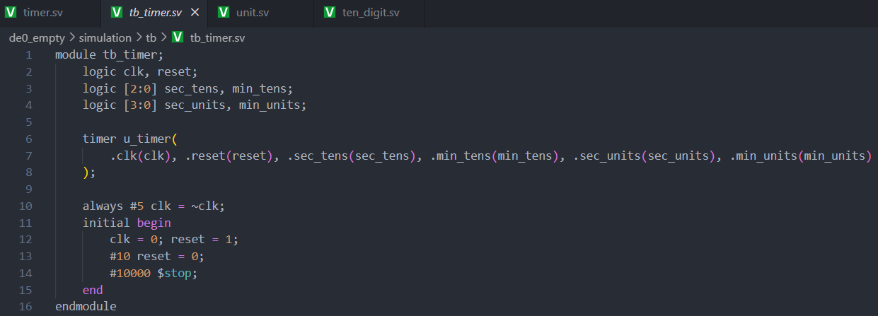
mcu.sv Code Screenshot
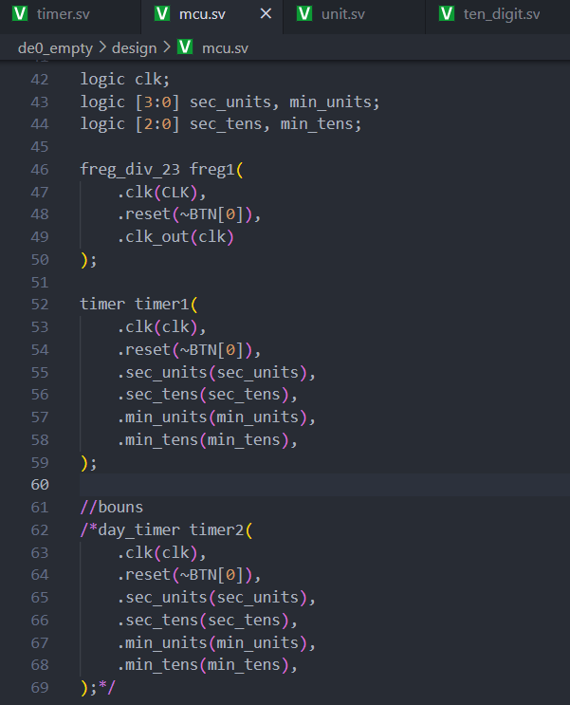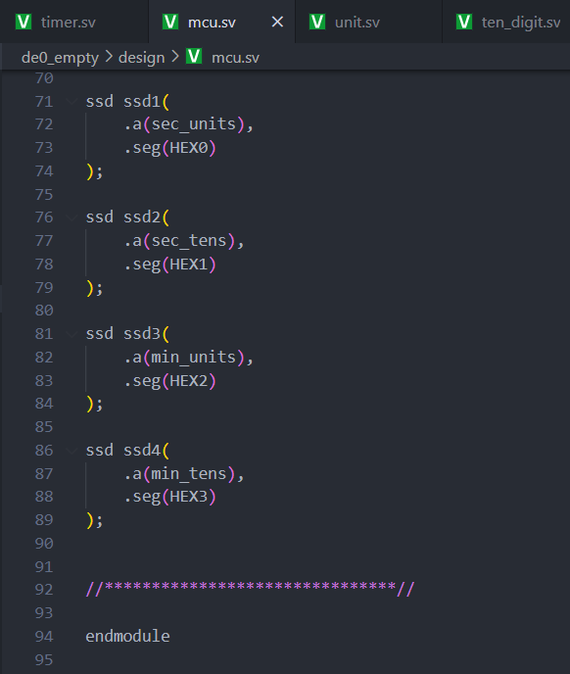
Waveform and Result Screenshot
(The values in the waveform must be clearly visible.)
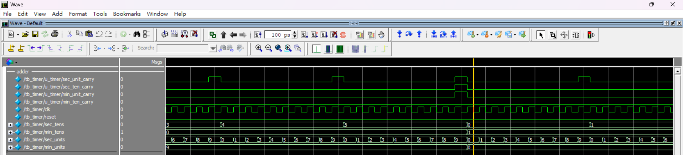
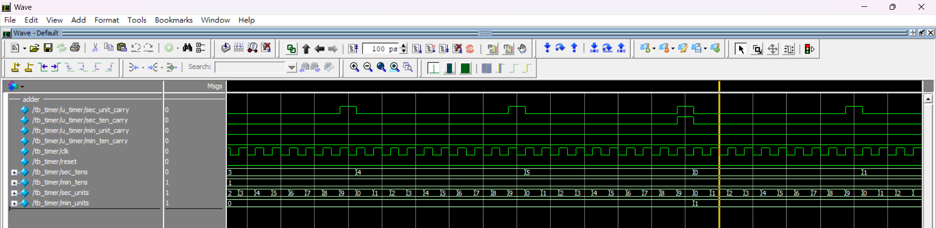

- Lab Summary and Reflection:
Summary
During this laboratory session, we were tasked with designing a 00:00–59:59 timer using D flip-flops within the Quartus environment on an Altera DE0 development board. The design process began by modularizing the counter into units and tens digits for both seconds and minutes: a four-bit D-flip-flop counter for the units digit that resets after reaching nine to generate a carry, and a three-bit counter for the tens digit that resets after five and propagates its carry to the next module. Karnaugh-map techniques were applied to derive minimized next-state equations for each D input, and corresponding SystemVerilog modules—unit.sv, ten_digit.sv, and dflipflop.sv—were instantiated within a top-level time.sv file. A comprehensive testbench was developed to simulate the expected counting sequence, and once the waveform matched the theoretical output, the signals were mapped to the HEX displays on the DE0 board through proper pin assignments for on-board verification .
In the bonus exercise, the counter was extended to serve as a 24-hour clock spanning 00:00 to 23:59. This extension involved introducing hour_units and hour_tens registers with conditional reset logic that triggers when the count reaches 24:00, forcing the circuit back to 00:00. The architecture diagram was updated accordingly, and the necessary modifications were made in SystemVerilog to implement this reset condition. Successful operation was again confirmed through both simulation and on-board testing .
Reflection
This laboratory experience deepened my understanding of synchronous digital design by reinforcing the process of translating state diagrams and tables into implementable HDL code and highlighting the value of Karnaugh-map simplification for optimizing logic. Building and verifying a modular counter architecture in SystemVerilog enhanced my appreciation for code reuse and abstraction, while debugging the testbench and interpreting waveform outputs sharpened my troubleshooting skills. Finally, deploying the design on the DE0 FPGA and interfacing with seven-segment displays provided practical insight into hardware-software integration challenges, such as pin mapping and timing considerations, lessons that will be invaluable in future digital system projects.

